1. How to compare two JSON have the same properties without order?
   1. var obj1 = { name: "Person 1", age:5 };
   2. var obj2 = { age:5, name: "Person 1" };

let obj={

    name:"ganesh",

    age:23,

}

let obj2={

    age:23,

    name:"ganesh"

}

   let isequal=(obj1,obj2)=>{

       let object1=Object.keys(obj);

       let object2=Object.keys(obj2);

       if(object1===object2){

           return true;

       }

       else{

           return false;

       }

   }

   console.log(isequal(obj,obj2))

0utput: false

1. Use the rest countries API url -><https://restcountries.eu/rest/v2/all> and display all the country flags in console

Solution:

var request = new XMLHttpRequest();

request.open("GET" ,"https://restcountries.com/v3.1/all" ,true);

request.send();

request.onload=function(){

    var data=JSON.parse(this.response);

       for(var nan in data){

           console.log(data[nan].flag)

       }

};

Output:

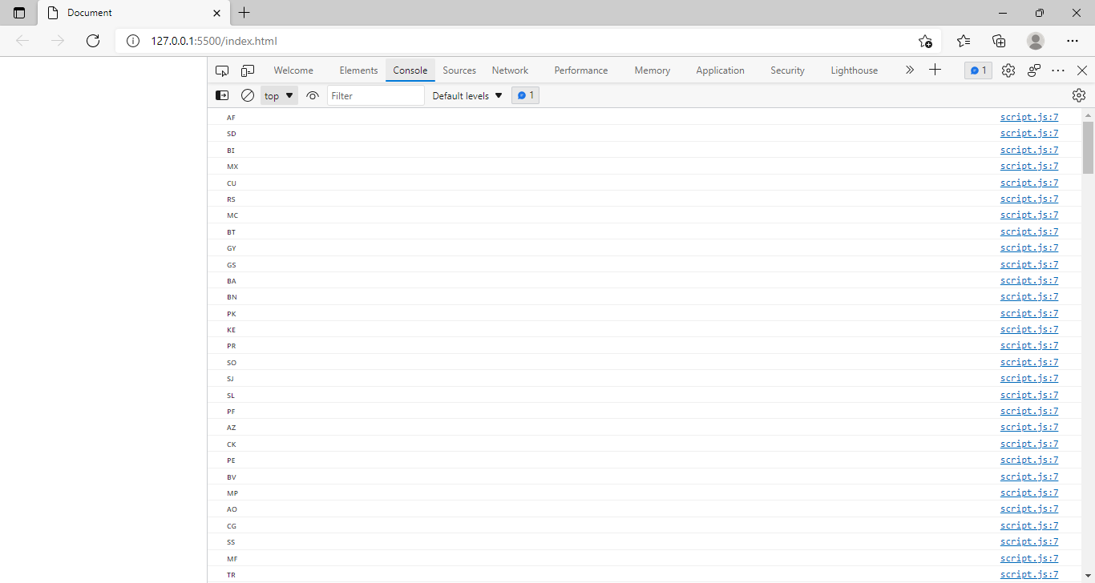

1. Use the same rest countries and print all countries name, region, sub region and population.

var request = new XMLHttpRequest();

request.open("GET" ,"https://restcountries.com/v3.1/all" ,true);

request.send();

request.onload=function(){

    var data=JSON.parse(this.response);

       for(var nan in data){

           console.log(`countries name: ${data[nan].name}

           region: ${data[nan].region}

           subregion: ${data[nan].subregion}

           population: ${data[nan].population}

           `);

       }

};

Output:

